ML ASSIGNMENT 1 (MODIFIED)

- Generate 10000 female samples using skewnorm.rvs(3,150, 5,10000)
- Generate 10000 male samples using np.random.normal(166, 5.5, 10000)
- Use test -train split to set aside 20% both male and female samples as test data
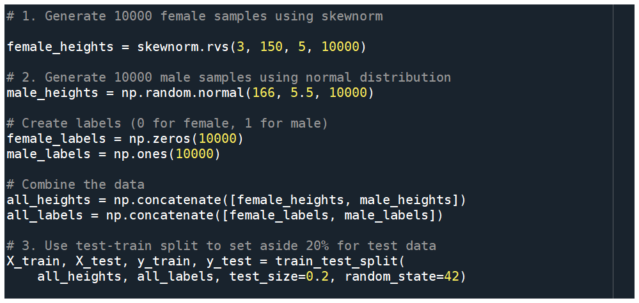

Output :

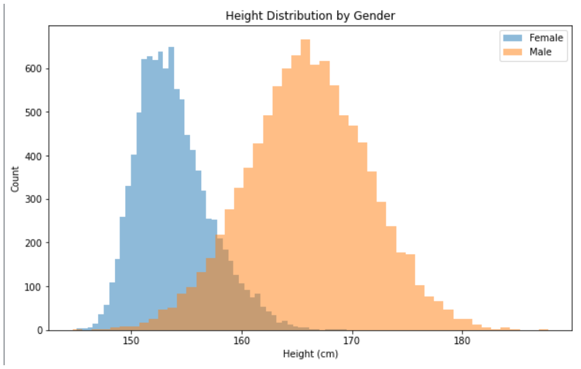

- Design a quantization/binning based classification algorithm as follows
  - Try bin sizes of 1 cm , 0.1cm , 0.01 cm………. upto 1/10^6
  - Shuffle the train data and set aside last 2000 rows of the train data as validation set and use first 6000 rows as new train set
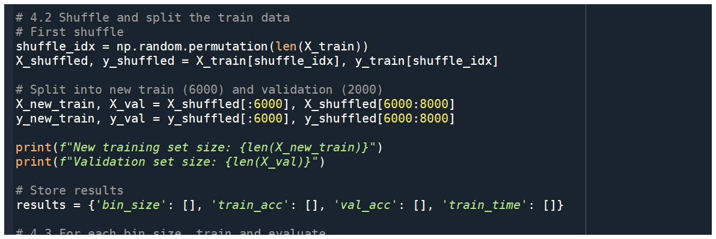

Why separate validation? This prevents overfitting by evaluating model performance on data not used for training but still separate from the final test set.
Observations: Using 6,000 samples for training and 2,000 for validation provides enough data for both while maintaining the original proportion.

  - For each bin size,
    - Train your model by using the new train set

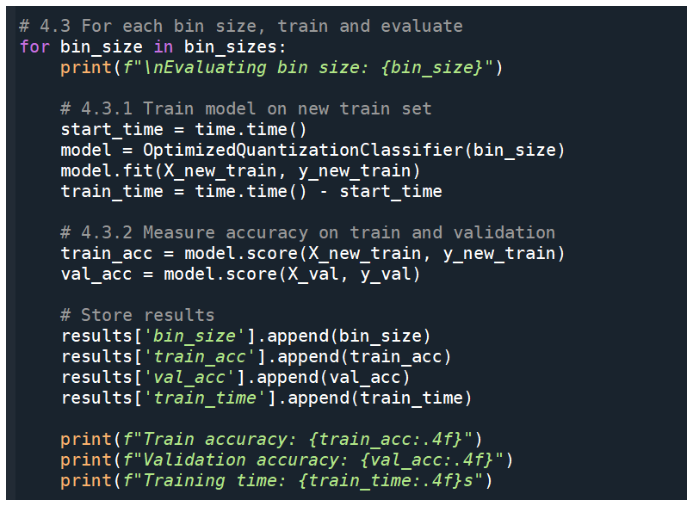
Classifier:
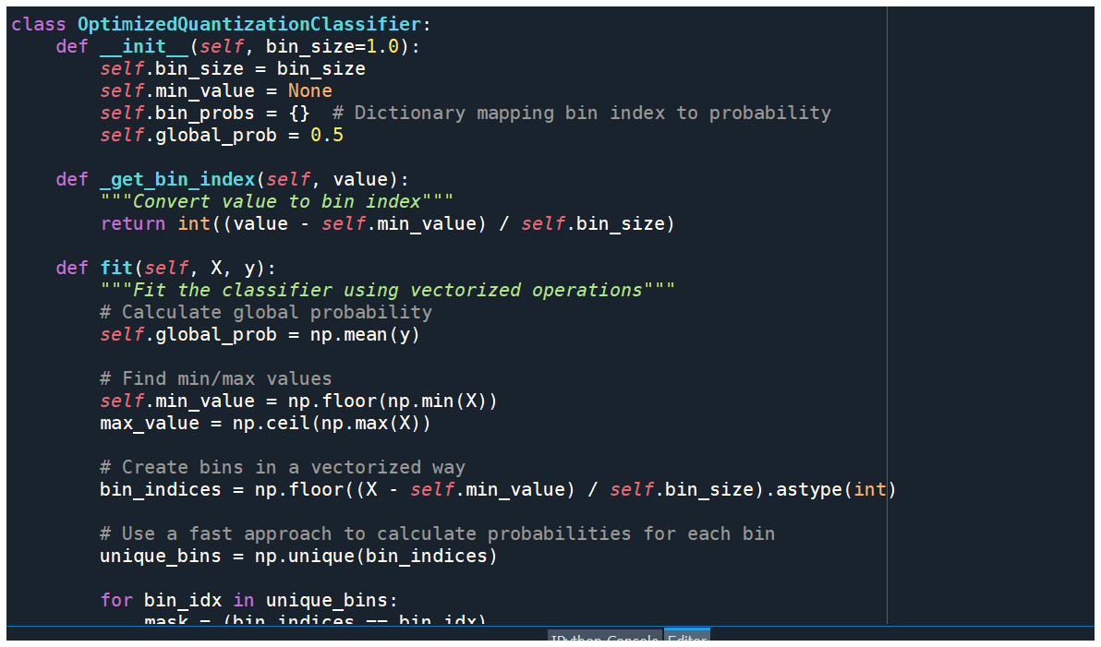
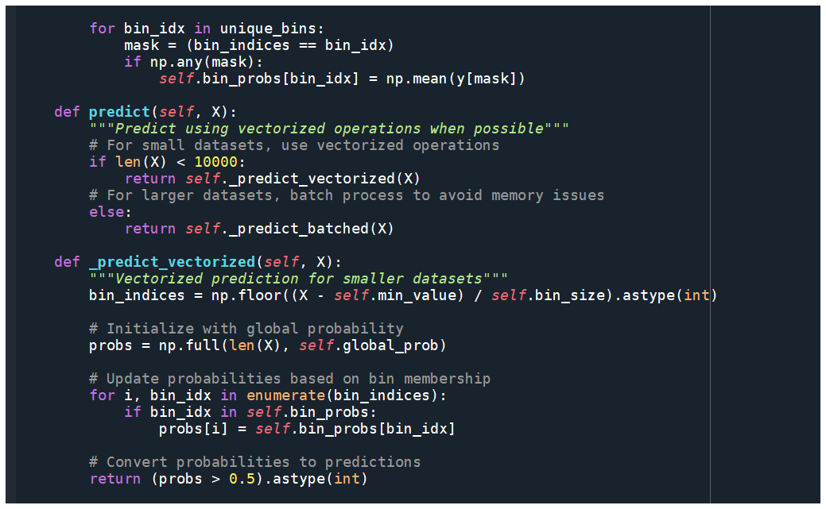
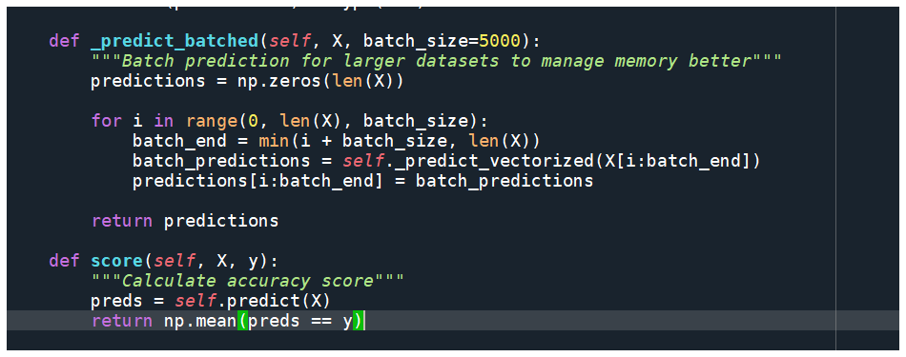

The classifier divides the range of height values into equal-sized bins and calculates the probability of being male within each bin.
- Fundamentals: Vectorization processes entire arrays at once using NumPy's C-level implementation and CPU's SIMD capabilities (Single Instruction, Multiple Data), making it 10-100x faster than Python loops by eliminating interpreter overhead; batching breaks large datasets into smaller chunks (e.g., 5,000 samples) to prevent memory overflows while preserving most speed benefits.
- Implementation: Vectorized operations apply transformations to all data simultaneously (e.g., bin_indices = np.floor((X - self.min_value) / self.bin_size).astype(int)), while batching processes these operations in manageable chunks using a loop structure (e.g., for i in range(0, len(X), batch_size)), combining the best of both approaches.
- Use cases: Vectorization is ideal for smaller datasets where memory isn't a concern and maximum speed is desired; batching becomes necessary for larger datasets where memory constraints exist or when processing extremely large arrays that could otherwise cause system crashes or significant slowdowns.
    - Measure accuracy using the hold out validation set of rows
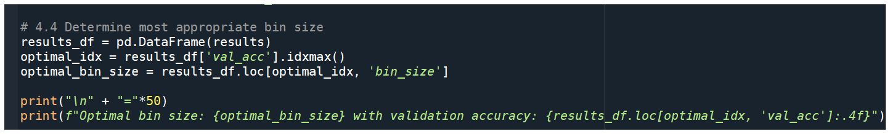
output :
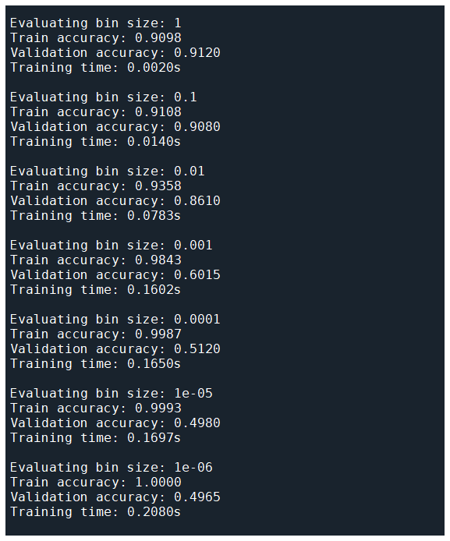

  - Use above data to determine most appropriate bin size
  - Train the model using the optimal bin size on the full train data and measure accuracy on test set.
Output :
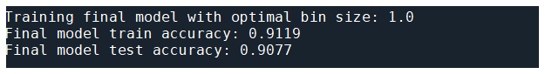
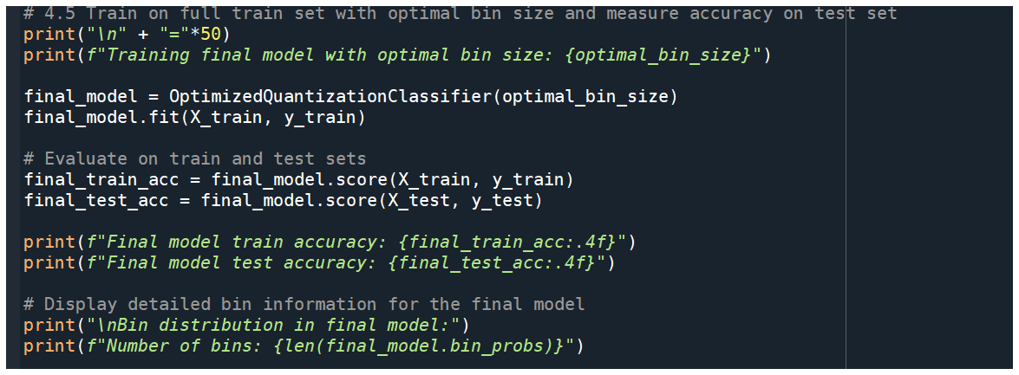
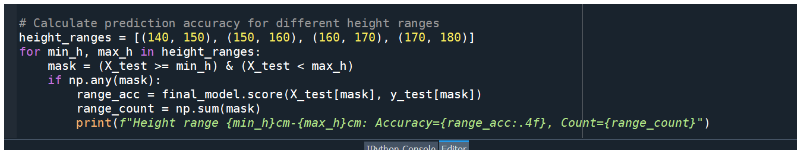
output :
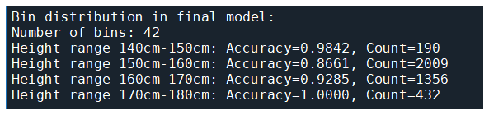

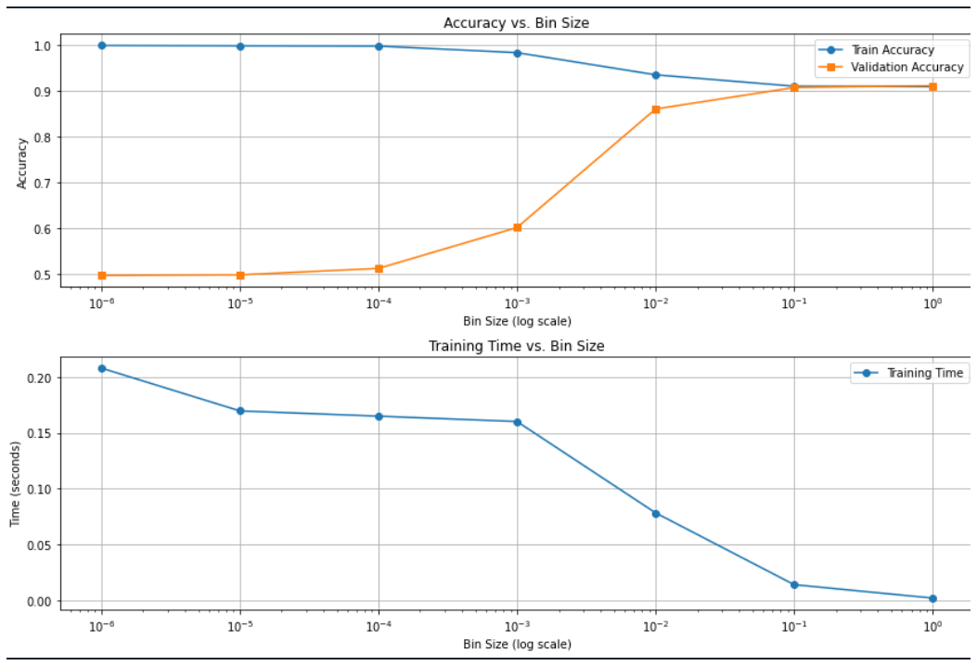

Observations:
- As bin size decreases, training accuracy typically increases
- Very small bin sizes often show a gap between training and validation accuracy (overfitting)
- Optimal bin size balances detail with generalization ability
- Training time increases for decreasing bin sizes.

KEY TAKEAWAYS:

Performance Across Height Ranges:
- Middle ranges (160-170cm): Lower accuracy due to significant overlap
- Extreme ranges (<150cm or >175cm): Higher accuracy as heights are more gender-specific
Computational Considerations:
- Smaller bin sizes dramatically increase training time and memory usage
- The optimized implementation uses dictionaries and vectorization to manage this
Bin Size Trade-offs:
- Very small bins (10^-6cm): Each bin might contain just one sample, leading to overfitting
- Optimal size: Captures meaningful patterns without memorizing noise

